Chirag solanki

15035

Homework assignment 3

Answer1

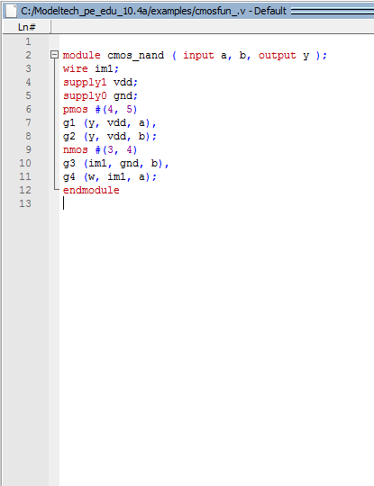

Answer 2

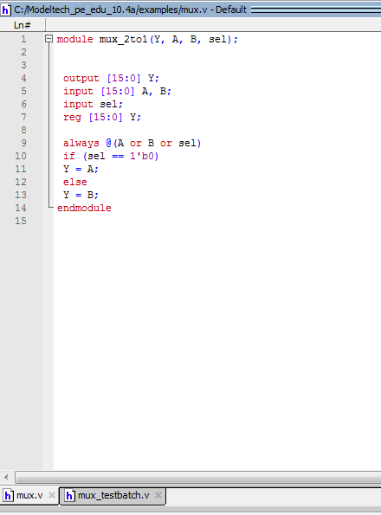

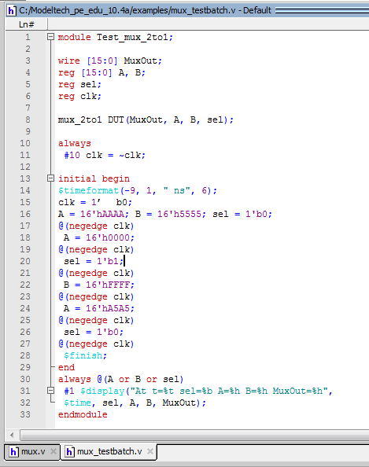

Answer 3

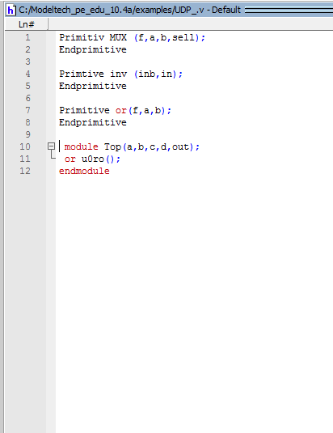

Answer 4

primitive crctp (x,A,B,C);

output x;

input A,B,C;

//Truth table for x (A,B,C) = Minterms (0,2,4,6,7)

table

// A B C : x ( this is only a comment)

0 0 0 : 1;

0 0 1 : 0;

0 1 0 : 1;

0 1 1 : 0;

1 0 0 : 1;

1 0 1 : 0;

1 1 0 : 1;

1 1 1 : 1;

endtable

endprimitive